Victoria Road Children’s Centre
February Half Term Event
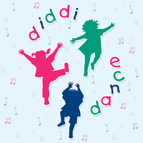
Diddi dance will be holding FREE taster sessions at Brio Leisure Centre on
Tuesday 19th February 2019
Sessions will be 12:30 – 1:15pm or 1:30 – 2:15pm
Suitable for children aged 18 months onwards, however if they’re younger but steady on their feet they are more than welcome to join in.
To check availability please ring Vicki on 07827 958259 or text your book your place.

