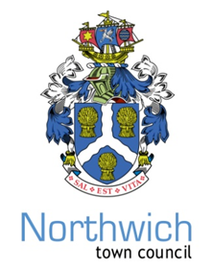
NORTHWICH TOWN COUNCIL
Town Clerk: Chris Shaw
Council Offices, 78 Church Road, Northwich, Cheshire, CW9 5PB - 01606 41510 www.northwichtowncouncil.gov.uk chrisshaw@northwichtowncouncil.gov.uk
DATE 22nd June 2022
To: The Members of Northwich Town Council’s Planning and Environment Committee.
Dear Councillor
You are summoned to attend the meeting of the PLANNING AND ENVIRONMENT COMMITTEE to be held in the Council Chambers on Monday 27th June, at 6.30 p.m.
Yours sincerely
Chris Shaw
Chris Shaw
Town Clerk
AGENDA
1. TO AGREE A CHAIR AND VICE CHAIR PROVISIONALLY NAMED.
Decision of Members requested.
2 APOLOGIES FOR ABSENCE OR ABSENCE
3 DECLARATION OF INTEREST Members to declare any interest under the following categories: * Pecuniary interest
* Outside bodies interest * Family, friend or close associate interest.

4 DISCUSSION NOTES
Of the Planning and Environment Committee discussion virtual meeting held on Thursday
26th May, 2022 and noted at the Full Council Meeting held on Monday 6thJune, 2022.

5 PLANNING APPLICATIONS
Schedule of planning applications will be submitted
Recommendations of the Committee are requested.

6. DECISION NOTICES.
To note CWAC Planning Committee Decisions on recent applications made (attached)

7 NEXT MEETING
To be held on Monday 24th July 2022 at 6.30 p.m.

Councillors:
Andrew Stott Andrew Cooper Derek Bowden Janet Illidge Tom Melville Catherine Fox
Graham Emmett Bob. Cernik Olwyn Dean Brian Holland

