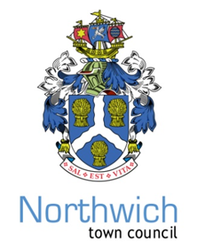
NORTHWICH TOWN COUNCIL
Town Clerk: Chris Shaw
Council Offices, 78 Church Road, Northwich, Cheshire, CW9 5PB - 01606 41510
www.northwichtowncouncil.gov.uk chrisshaw@northwichtowncouncil.gov.uk

Dear Councillor
You are summoned to attend the Annual General Meeting of the NORTHWICH TOWN COUNCIL to be held in the Council Chamber at 6.00 pm on Monday 15th May 2023.
Yours Sincerely
Chris Shaw
Chris Shaw Town Clerk
AGENDA
At 6.00pm, the Clerk will announce the entrance of the
Town Mayor Councillor Graham Emmett
1. Apologies for absence or absence.

2. To elect the Town Mayor for 2023/24

3. To elect the Deputy Town Mayor 2023/24

4. To approve list of Members of Committees and Representatives on Outside Bodies

5. To agree Northwich Town Council Standing Orders

6. To note attendance at Northwich Town Council Meetings

7. To agrees meeting Calendar 2023/24

8. To resolve to adopt SLCC Civility & Respect Pledge

9. To approve awarding of the Contract to build the refurbished skatepark at Vickersway Park.

