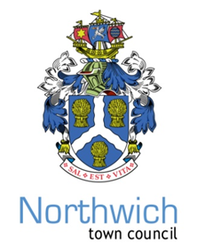
Dear Councillor
The TOWN MEETING FOR THE PARISH OF NORTHWICH will be held on Monday 15th MAY 2023 AT 5.00 pm to be held in the Council Chamber.
The above meeting, which has been advertised locally, consists of local government electors for the Parish of Northwich and the Chair will be taken by the Town Mayor.
Yours Sincerely
Chris Shaw
Chris Shaw Town Clerk
AGENDA

1. Apologies for absence or absence

2. Declaration of interest

Members to declare any interest under the following categories: * Pecuniary interest * Outside bodies interest * Family, friend or close associate interest

3. Minutes of the Town Meeting for the Parish of Northwich held on Friday 6th May 2022 and approved on Monday 6th of June 2022 will be displayed in the Council Chamber.

4. Mayors Remarks—Review of the year, in conjunction with the Town Council Annual Report 2022/23 hereby presented for public comment.

5. To discuss any matters in relation to the affairs of the Parish of Northwich and if appropriate, to pass resolutions thereon for consideration by the Town Council.

NORTHWICH TOWN COUNCIL
Town Clerk: Chris Shaw
Council Offices, 78 Church Road, Northwich, Cheshire, CW9 5PB - 01606 41510 www.northwichtowncouncil.gov.uk chrisshaw@northwichtowncouncil.gov.uk

