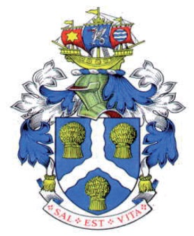


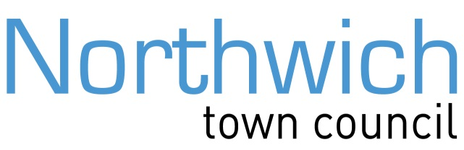

The Council Offices
78 Church Road
Northwich
Cheshire
CW9 5PB
Tel: 01606 41510

Email: townmayor@northwichtowncouncil.gov.uk

13th October 2026

Dear Louise, Karen and Rob,

I am writing to you in my capacity as Mayor of Northwich to formally register the deepest concerns of Northwich Town Council and our residents regarding the ongoing developments at the Wallerscote lime beds. You will be aware that Tata Chemicals plan to construct a solar farm on the old alkali waste beds which, initially, had everyone’s approval. However, it became clear that the developers wanted to dump millions of tons of industrial rubble onto the site to provide a solar panel base. We believe this is an unnecessary but potentially lucrative for the developers. It would also involve the movement of ~200 trucks per day over Winnington swing bridge or Moss Lane, both pinch points with the former being a structurally delicate.

We are fully aware that the Planning Inspectorate overturned the local planning refusal on appeal. However, new and very serious risks have been identified in the structural stability of the bund walls and the lime bed floors. It should be remembered that these beds have not been engineered but have received decades of passive lime waste dumbing. Parts of the embankment are around 30 metres high, formed from accumulated furnace ash, and have suffered serious failures in the past.

Would you therefore confirm the Council’s understanding and awareness of the embankments’ construction and history and provide the relevant engineering assessments in your possession. I would also be grateful if you would provide a work plan (or similar) regarding the discharge conditions for the Wallerscote Lime Beds plan especially regarding the integration of the information summary below.

Coffey’s monitoring reports describe a longstanding crack along the northern embankment between BH06 and BH07. Its Q1 2026 report records that one crack feature lengthened from 49 metres in Q1 2025 to 55.2 metres in Q4 2025. Coffey says this may indicate an ongoing deep-seated failure and rates the risk of bank failure as HIGH. It calls for a thorough stability review as soon as possible. The report does not assess how the proposed infilling could affect stability.

Coffey also warns that a failure could bring substantial clean-up and reconstruction costs, as well as reputational and wider business impacts. The reports available to us do not clarify the risk to life and limb or the emergency arrangements.

Please find attached the updated Coffey report highlighting the increased likelihood (evidenced by the continued crack movements) that the risk of bank failure is considered HIGH.”

Please would you urgently confirm what current engineering assessment and monitoring are in place, who is responsible for addressing the risks, what emergency plans protect residents, and how CWAC has verified compliance with the relevant planning conditions. We ask the Council to arrange an urgent site inspection and explain what steps it can take to prevent further infilling until the risks have been properly assessed.

Residents need to know that public safety is being treated as the priority. I look forward to your urgent response.

Yours sincerely

Cllr Robert Cernik
Northwich Town Mayor

